Name : d.madan kumar

Reg no : 192111559

Course Code : CSA0726

**COMPUTER NETWORKS LAB EXPERMIENTS**

**DAY-3**

1. **IOT Based Smart Home Using Cisco Packet Tracer**

**AIM :** to create IOT Based Smart Home Using Cisco Packet Tracer

step1:-first take home gateway

step2:-link that server with celling fan and window

step3:-connect that celling fan and window with connection of smart phone

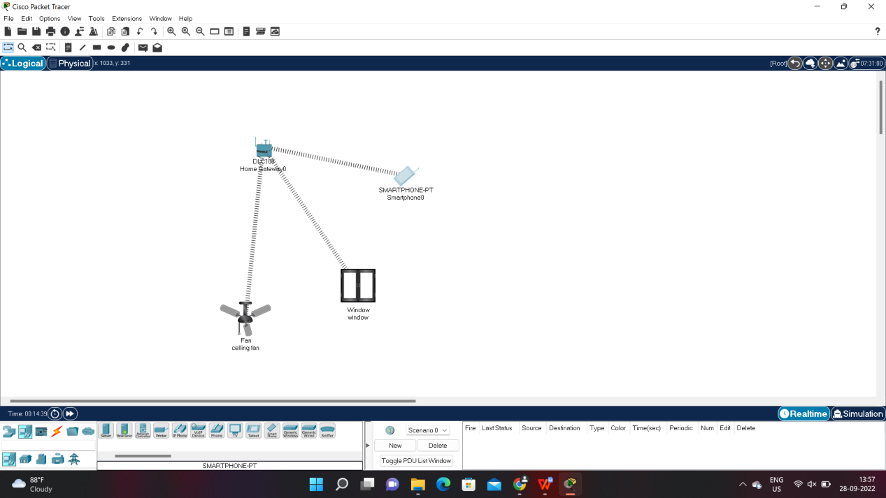

step4:- after connection celling fan and window with connection of smart phone

Check the connection with the appliances

step5:- if message send correctly you got successfull other wise recheck the connections

Step6:- then the celling fan and window with connection of smart phone

Check the connection with the appliances is successfully simulated and the appliances are working .

